Hawi

**Section 77745 (Group 4)**

|  |  |  |
| --- | --- | --- |
|  |  |  |
| Student Name | ID | Tasks |
| Fanar Barboud | 445200050 | Service, Service Details, Provider Dashboard, Add Service , Manage Staff Member and Favorite Pages. |
| Jumana Alhumud | 445201376 | About us , Staff Member Pages and Word document. |
| Dalia Alotaibi | 445202288 | Home Page. |
| Wajd Alrasheed | 445200283 | Customer Dashboard ,Request Service, Evaluate Service Pages and Word document. |

New Sitemap :

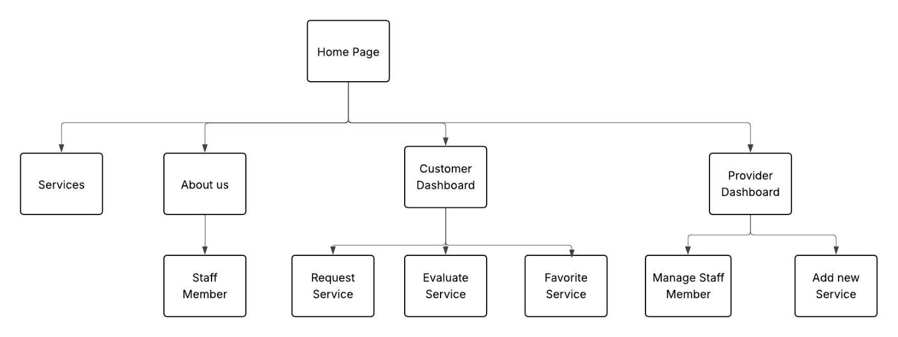

**New CSS Rules Applied to Extra Functionalities and Section:**

**Pages Layout:**Page1: Homepage

|  |
| --- |
| Print Screen |
|  |
| Wireframe |
|  |

Page1: Services

|  |
| --- |
| Print Screen |
|  |
| Wireframe |
|  |

Page2: About Us

|  |
| --- |
| Print Screen |
|  |
| Wireframe |
|  |

Page3: Staff Member

|  |
| --- |
| Print Screen |
|  |
| Wireframe |
|  |

Page4: Customer Dashboard

|  |
| --- |
| Print Screen |
|  |
| Wireframe |
|  |

Page5: Request Service

|  |
| --- |
| Print Screen |
|  |
| Wireframe |
|  |

Page6: Evaluate Service

|  |
| --- |
| Print Screen |
|  |
| Wireframe |
|  |

Page7: Favorites

|  |
| --- |
| Print Screen |
|  |
| Wireframe |
|  |

Page8: Provider Dashboard

|  |
| --- |
| Print Screen |
|  |
| Wireframe |
|  |

Page9: Add Service

|  |
| --- |
| Print Screen |
|  |
| Wireframe |
|  |

Page10: Manage Staff Member

|  |
| --- |
| Print Screen |
|  |
| Wireframe |
|  |

**Chatbot usage:**

**Validation:**

|  |  |
| --- | --- |
| **Chat Number** | **1** |
| **Chatbot** | **ChatGPT** |
| Page or code title | **css.css** |
| **Screenshot of the question** |  |
| **Screenshot of the answer** |  |
| Problem solved or no (useful or no) | **Useful** |

**Image generation:**

|  |  |  |  |
| --- | --- | --- | --- |
| **S** | **Image file name** | **image** | **Chatbot** |
| **1** | **fahad.jpeg** |  | **ChatGPT** |
| **2** | **maha.jpeg** |  | **ChatGPT** |
| **3** | **noura.jpeg** |  | **ChatGPT** |
| **4** | **Logo.png** |  | **ChatGPT** |